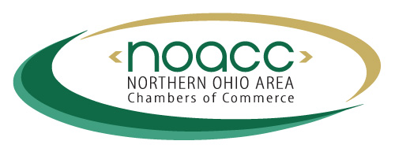
NOACC Cost-Savings Benefits

Available to All Members

www.noacc.org
Group Health Insurance – Chamber Saver Program
Full range of health insurance plans with cost savings. Businesses also get access to a large network of quality providers through Anthem, an independent licensee of the Blue Cross and Blue Shield Association. Premium savings of up to 1.4% on groups from 2-50 employees. Groups from 51-500 may be eligible for a 1% premium savings. Business must be a member of a NOACC Chamber. For a quote, contact your local broker or visit noacc.org.

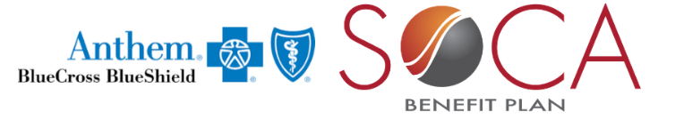 www.noacc.org
Group Health Insurance – SOCA Benefit Plan (MEWA)
The SOCA Benefit Plan MEWA, administered by Anthem, is a smart solution for groups with 50 or fewer employees and sole proprietors. It allows smaller employers to join together to share in the overall claims risk, backed by Anthem stop loss coverage. Business must be a member of a NOACC Chamber. For a quote, contact your local broker or visit noacc.org.
www.ceateam.com/chamber
Chamber Energy Program
Community Energy Advisors (CEA) is a Public Utilities Commission of Ohio (PUCO) certified energy management firm that educates and empowers organizations to maximize the economics of their energy assets. By staying one step ahead of changes in the energy industry and utilizing analytics, advanced tariff modeling and reporting, CEA delivers a multitude of energy management solutions that positively impact customers’ utility bill costs. Business must be a member of a NOACC Chamber. For a free quote, visit ceateam.com/chamber.

www.hmssolutions.com

Managed Care Organization (MCO)
Workers’ Compensation is a major cost of doing business. Lost-time claims can increase premiums if not handled properly. It is the MCO’s job to make sure injured workers receive care and return to work safely and promptly. NOACC Chambers and their business members will be able to choose HMS (Health Management Solutions) and be assured that they can rely on their MCO to protect their workers and their bottom line. Business must be a member of a NOACC Chamber.

