NOACC Benefit and Participation Descriptions

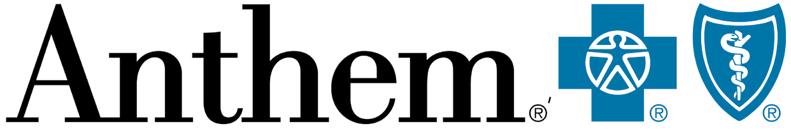 www.844medohio.com
Group Health Insurance – Chamber Saver Program
Full range of health insurance plans with cost savings usually reserved for larger companies. Businesses also get access to a large network of quality providers through Anthem, an independent licensee of the Blue Cross and Blue Shield Association. Premium savings of up to 1.4% on groups from 2-50 employees. Groups from 51-500 may be eligible for a 1% premium savings. Business must be a NOACC Chamber Member.

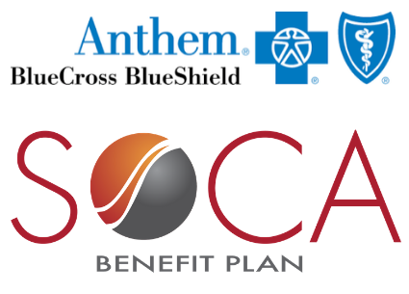 www.844medohio.com
Group Health Insurance – SOCA Benefit Plan (MEWA)

Chambers of Commerce throughout Ohio have banded together to offer a new self-funded medical plan for small employers. The Northern Ohio Area Chambers of Commerce (NOACC), Central Ohio Chambers of Commerce, Southern Ohio Chamber Alliance (SOCA), Dayton Area Chamber, and the Youngstown Warren Regional Chamber have collaborated to create a new health program that can lead to more rate stability and is a smart solution that offers potential savings for groups with 50 or fewer employees. Business must be a NOACC Chamber Member.

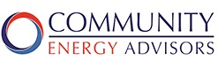 www.ceateam.com/chamber/
Chamber Energy Program

Community Energy Advisors (CEA) is a Public Utilities Commission of Ohio (PUCO) certified energy management firm that educates and empowers organizations to maximize the economics of their energy assets. By staying one step ahead of changes in the energy industry and utilizing analytics, advanced tariff modeling and reporting, CEA delivers a multitude of energy management solutions that positively impact customers’ utility bill costs.

 www.heartland.us
Chamber Payments/Billing & Payroll/HR Programs

Helping businesses prosper through innovative solutions, advocacy, and unmatched service is Heartland’s mission. Never veering from our convictions, Heartland has led the industry in transparency, integrity, and security. Today, Heartland delivers credit/debit/prepaid card processing, payroll, and payment solutions to more than 300,000 businesses and educational institutions nationwide.

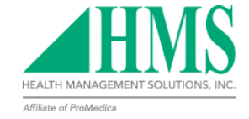 www.hmssolutions.com

Managed Care Organization (MCO)

Workers’ Compensation is a major cost of doing business. Lost-time claims can increase premiums if not handled properly. It is the MCO’s job to make sure injured workers receive care and return to work safely and promptly. NOACC Chambers and their business members will be able to choose HMS (Health Management Solutions) and be assured that they can rely on their MCO to protect their workers and their bottom line.

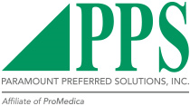 www.paramountpreferredsolutions.com
Workers' Compensation Group Rating Programs

By joining a Workers’ Comp Group Rating program businesses up to 500 employees can achieve rate reductions on Ohio BWC premiums up to the maximum discount allowed. With offices in Cleveland and Toledo, PPS TPA Services is locally owned and operated in Northern Ohio. We promise to meet with you at your business or Chamber offices! Contact us for a Free, No Obligation Assessment of the best cost reduction programs for your company.

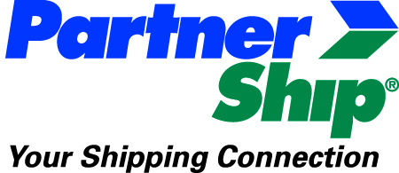
NOACC Chamber Shipping Program www.PartnerShip.com/89NOACC

Chamber members can achieve substantial shipping discounts with FedEx®, as well as significant savings on freight shipments—with the opportunity for NOACC affiliated Chambers to earn non-dues revenue. Savings from 5-27% on small package ground, next day air, or up to 70% savings on large pallet shipments.

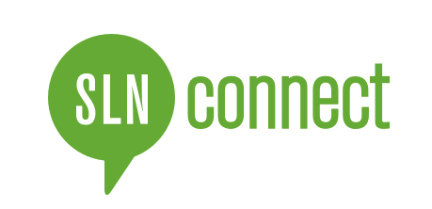
Digital Marketing Services www.slnconnect.com

Manage all digital marketing from one, easy-to-use platform
SLNConnect is a digital marketing tool that chambers can pass to any member. They provide tools to grow your chamber and help members succeed. Be found with a search optimized & mobile responsive landing page. Send targeted emails to your customers in minutes. Create unlimited search optimized content to engage. Share to social in one click. Track your marketing success on one dashboard.

www.noacc.org

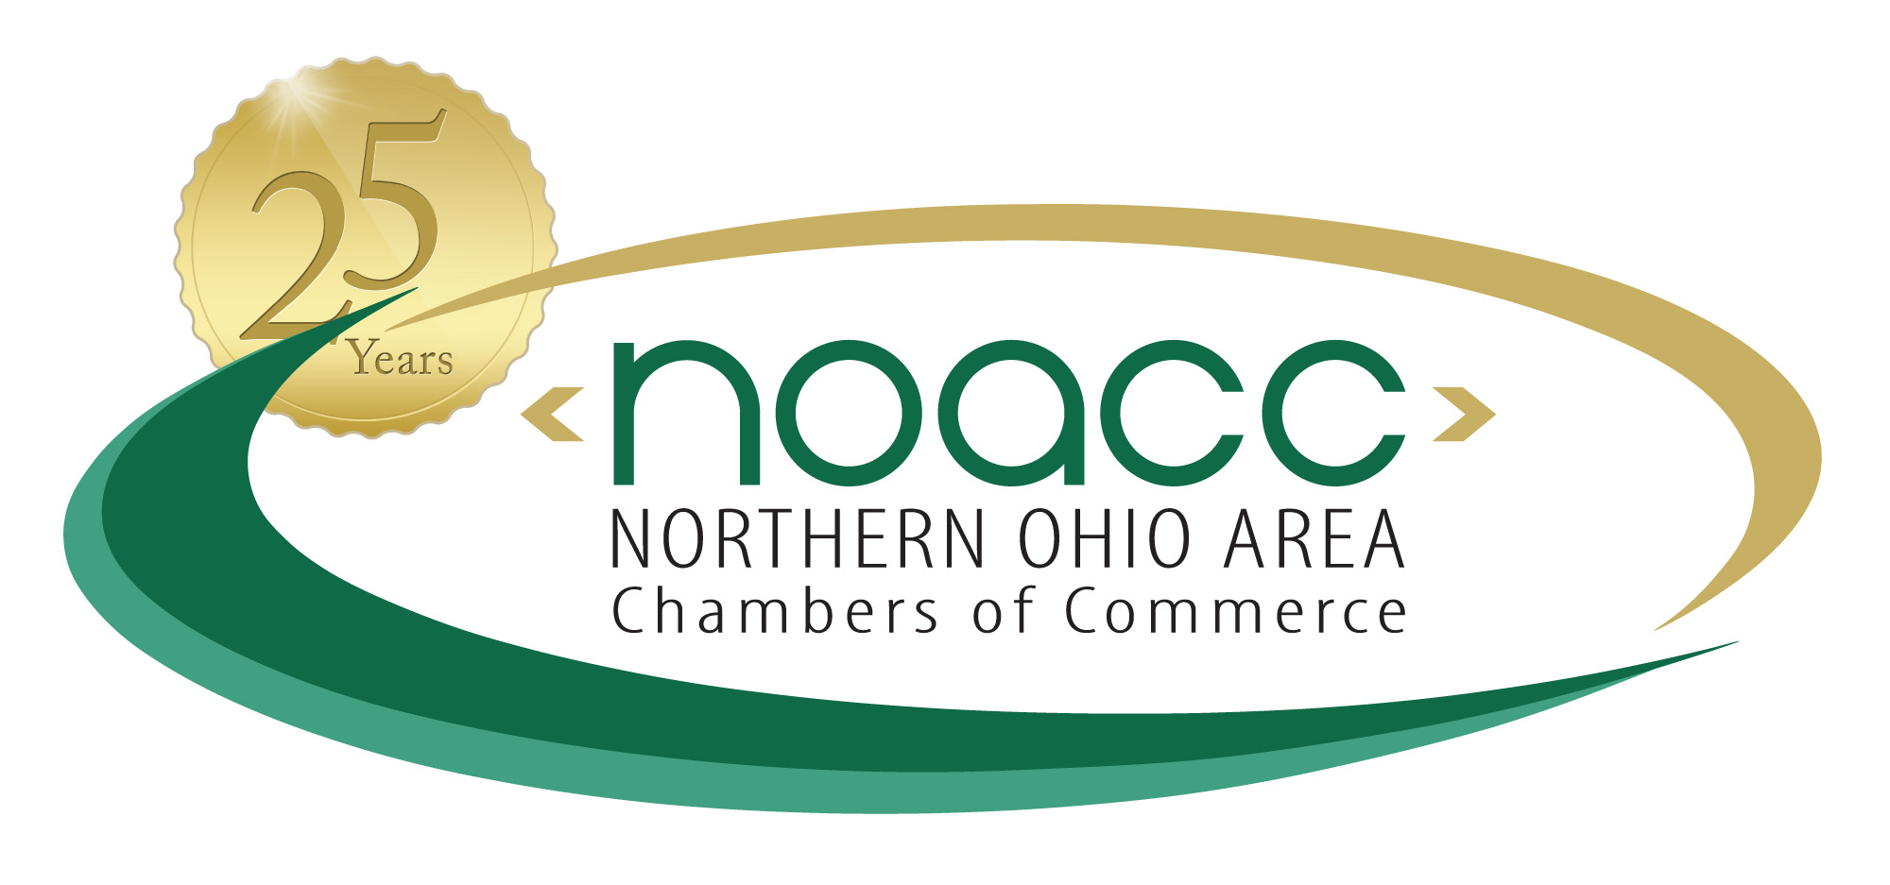
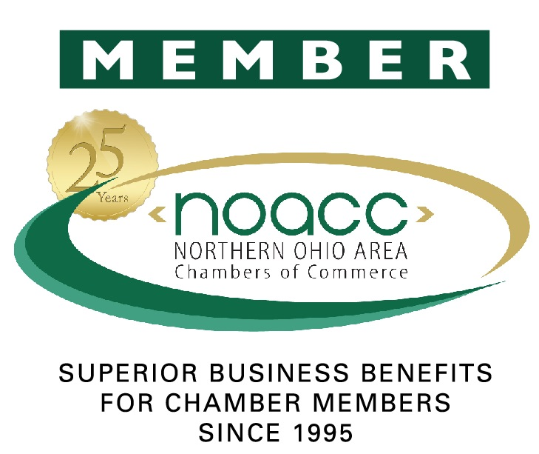

For questions or for more information about these programs, please contact Cindy Holzheimer, President/CEO of NOACC at director@noacc.org or at the phone numbers below.

A regional partnership of local chambers dedicated to helping chambers and their members

PO BOX 3230 ▲ CUYAHOGA FALLS, OHIO 44223

PHONE (216) 447-9900 ▲ TOLL FREE (866) 466-6222 ▲WWW.NOACC.ORG

