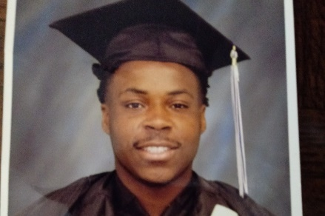
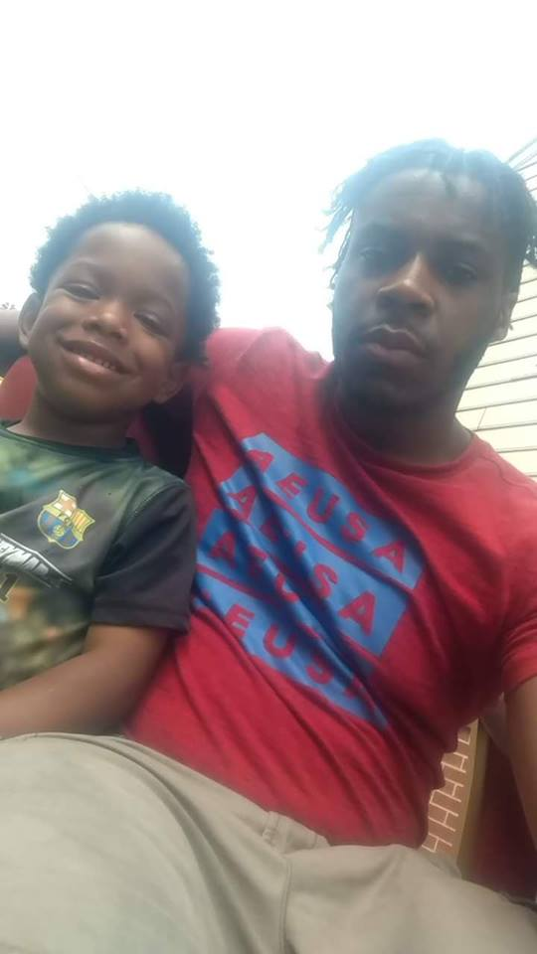
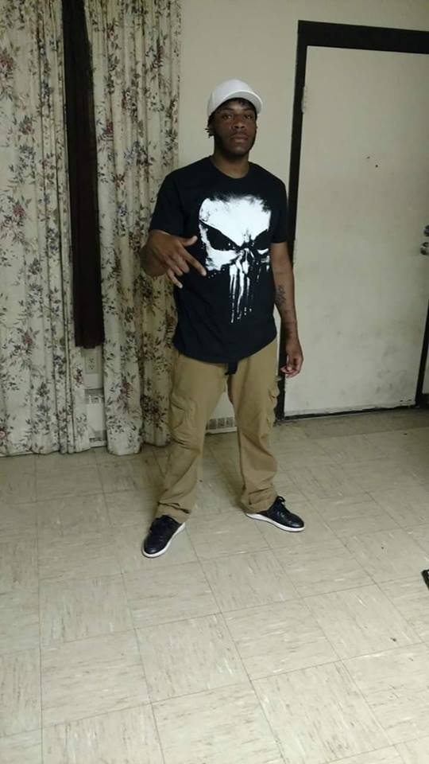
Come Join Us
Benefit Cookout
July 8th
3 p.m.-7 p.m.
Come join us for a Benefit Cookout where
we will be hosting a cookout, games,
Chinese Auction, 50/50, kids face painting, and
contests to help raise money for the cost of
Clayton Benders funeral costs.
All proceeds will be donated to
Claytons Family
Cornhole Contest
$5 Entry
1st and 2nd place teams win prizes

Face painting for kids
$3
Alpine House of Ravenna
7000 State Route 88
Ravenna OH 44266

Grilled burgers and hotdogs
Pasta salads
Refreshments
Auction ticket
$8
Children 5 and under eat free
Live Entertainment
Children 12 and under
$4
Bowling Tournament for kids
$4 Entry
1st 2nd and 3rd place prizes.

